CS 255 System Design Document Template

This template lays out all the different sections that you need to complete for Project Two. Each section has guidance to prompt your thinking. You will need to continually reference the interview transcript as you work to make sure that you are addressing your client’s needs. There is no required length for the final document. Instead the goal is to complete each section based on what your client’s needs are. Remove this note when you are finished, and replace all bracketed text with the relevant information.

UML Diagrams

UML Use Case Diagram

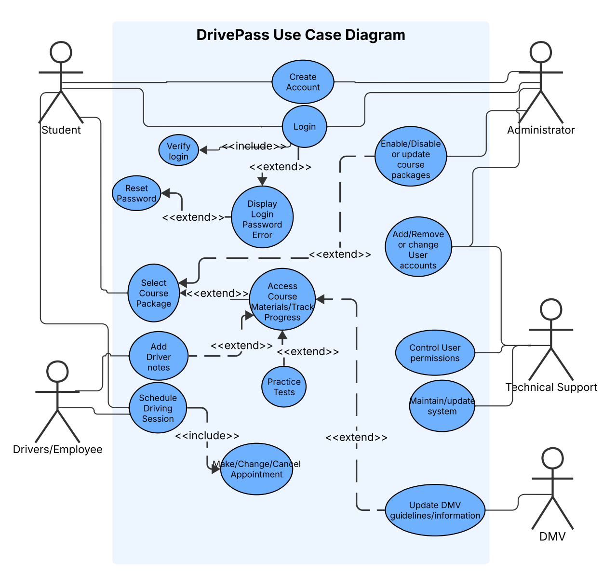

UML Activity Diagrams

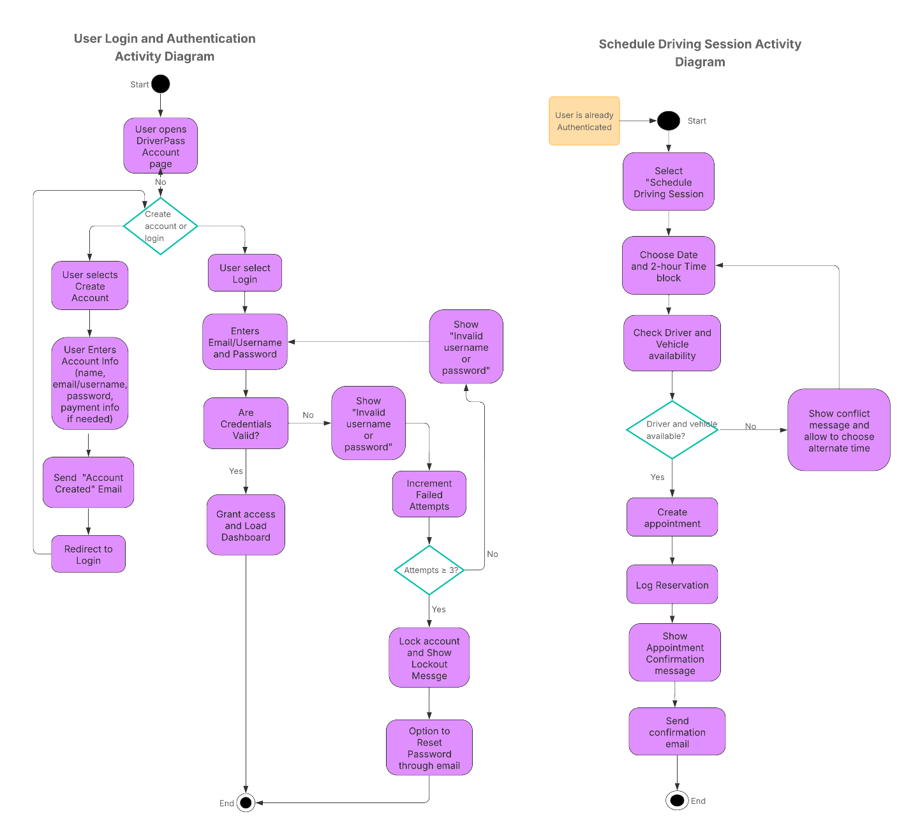

UML Sequence Diagram

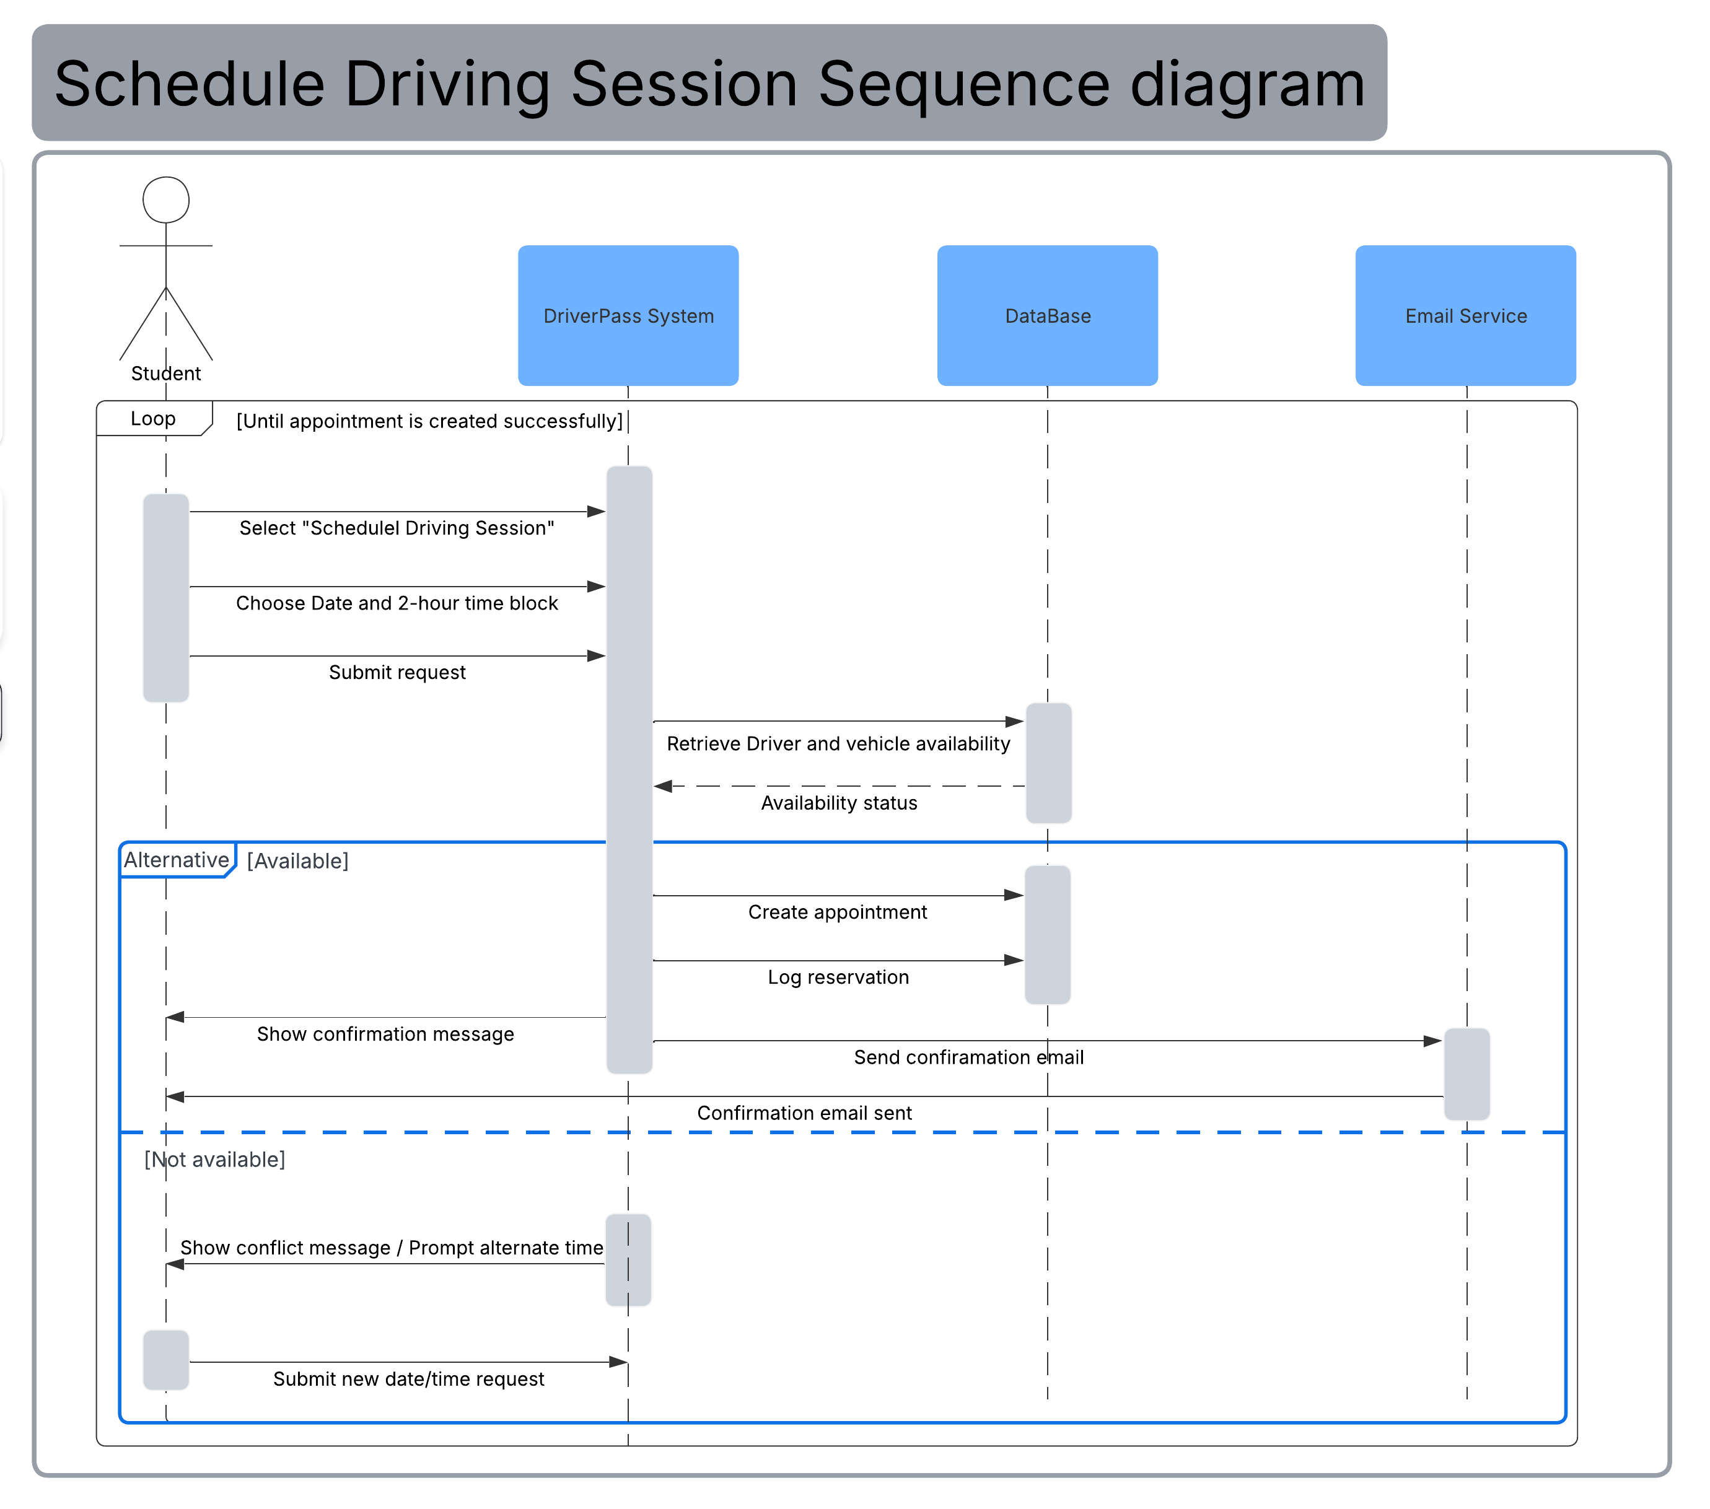

UML Class Diagram

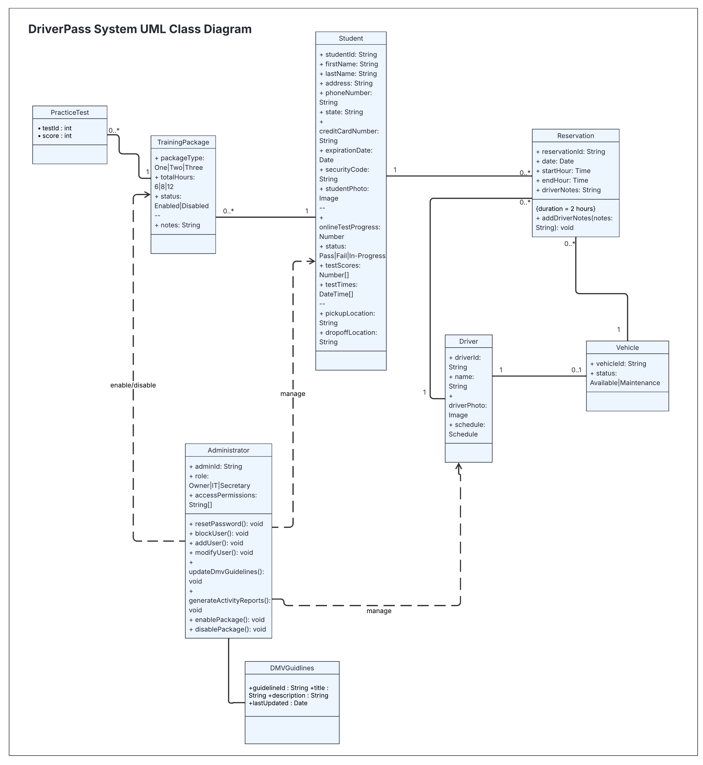

Technical Requirements

Based on the diagrams I have created, the DriverPass system is required to be a web-based system that supports secure logins, scheduling for the driving sessions, and storing important user information. Since students, drivers, administrators, and technical support will access the system online they will need either a desktop, laptop, or mobile device that has internet access. The system will also need a web application with both front-end and back-end components, along with a relational database to store data like student profiles, driver information, vehicles, reservations, training packages, and DMV guideline information. Security features such as encrypted passwords, account lockout after multiple failed attempts, and role-based access control is necessary to protect the user information as well as controlling who has access to certain functions. Additionally, this system will need reliable hosting, through either a cloud provider or a dedicated server, which according to the interview transcript, cloud is preferred. It will also need secure network connections using HTTPS encryption to protect sensitive user and payment information. An integrated email service will also be necessary as well to send account confirmations and appointment notifications. The system should also include automated database backups, monitoring tools, and a basic firewall protection to help the system stay secure.

